**User Manual**

* Presentation

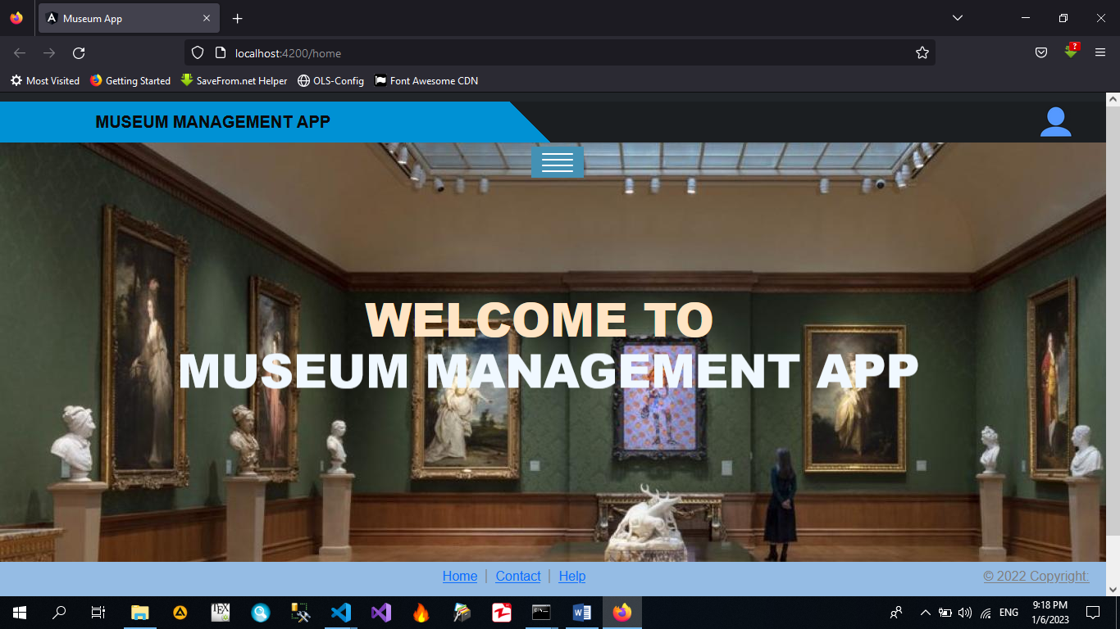

* Click in the menu to select the museums by types.

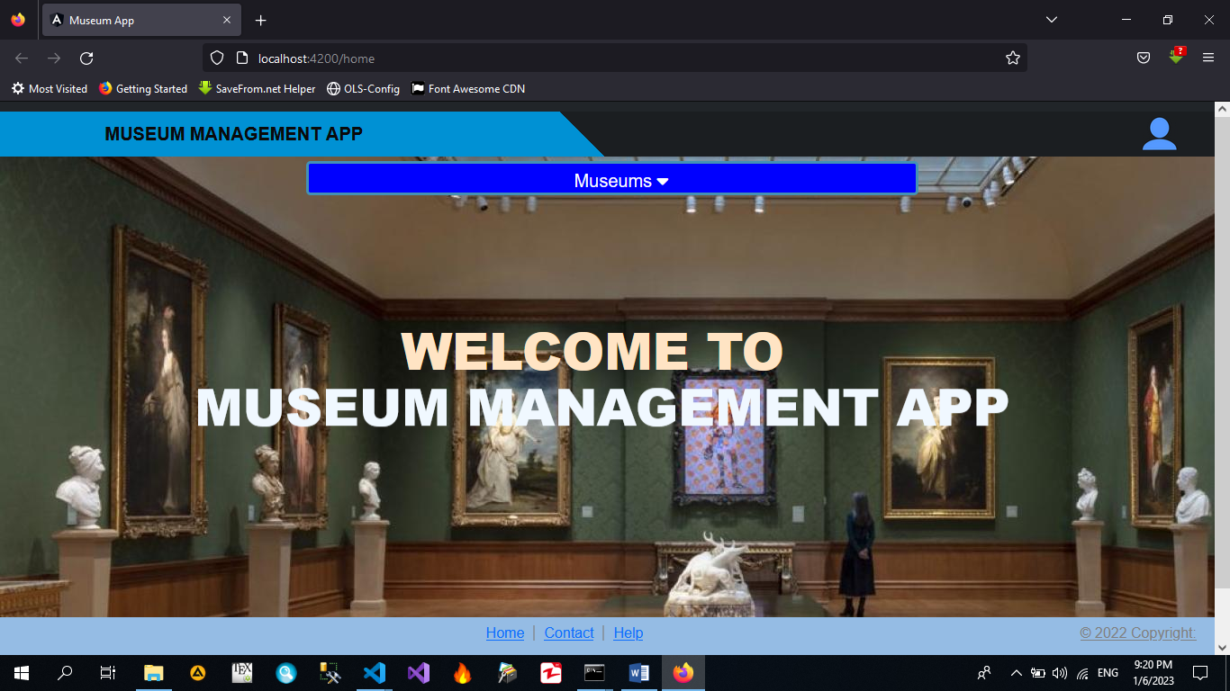

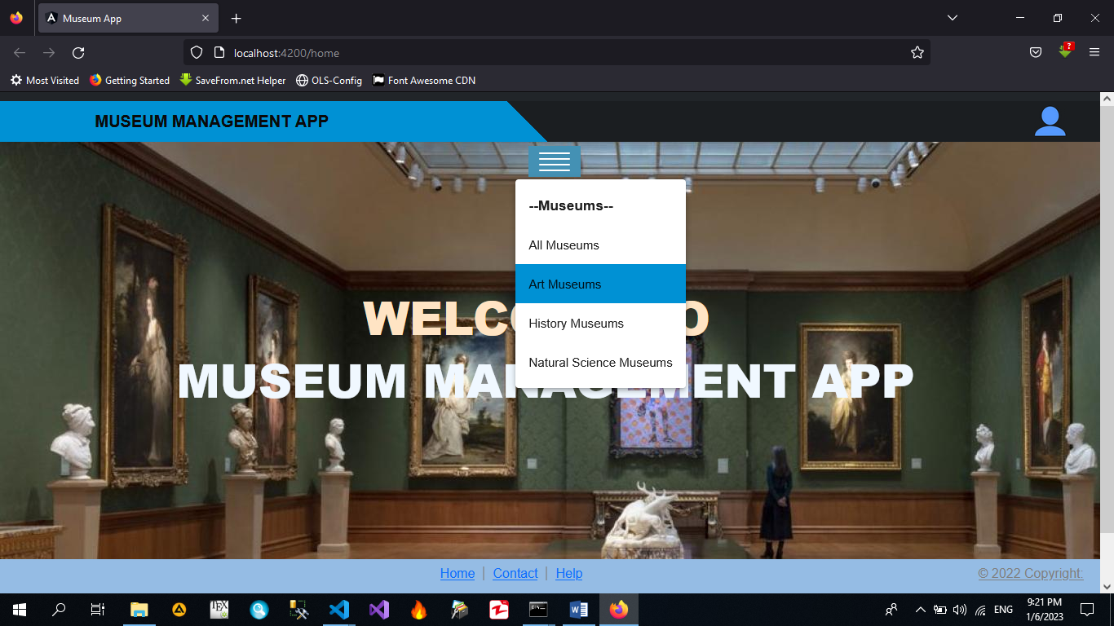

* You may select AllMuseums or Art, History and Natural Science Museums. If we select Art Museums then appear a view with the museums which have the type Art.

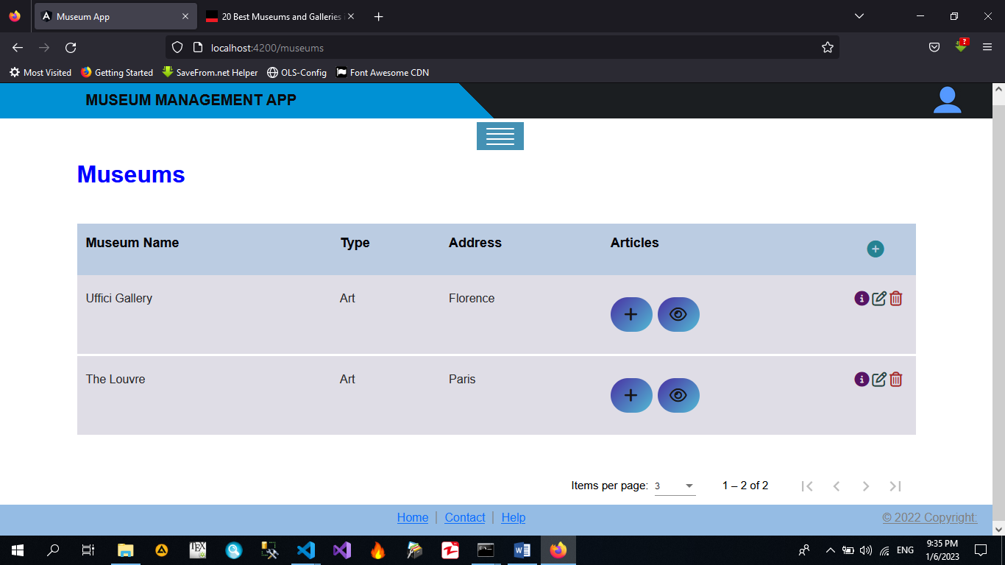

* In the previous View we can see the information of the museums, delete, edit, and create museums. A paginator was implemented too. If we click on create button, we will see:

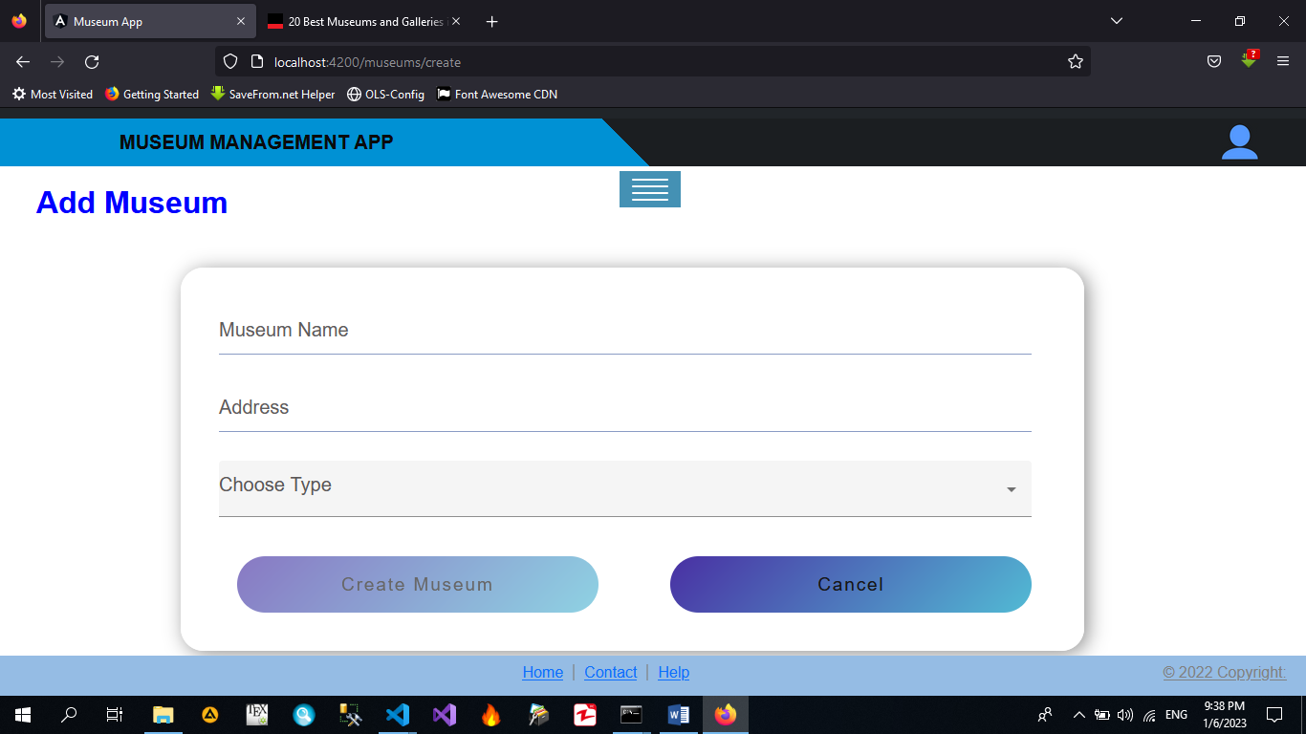

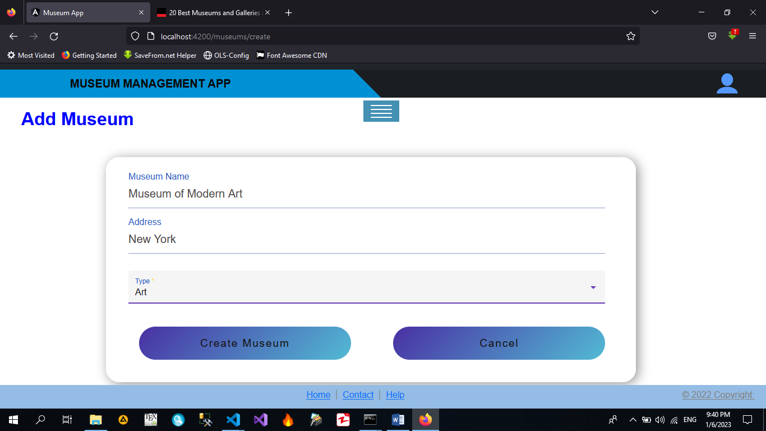

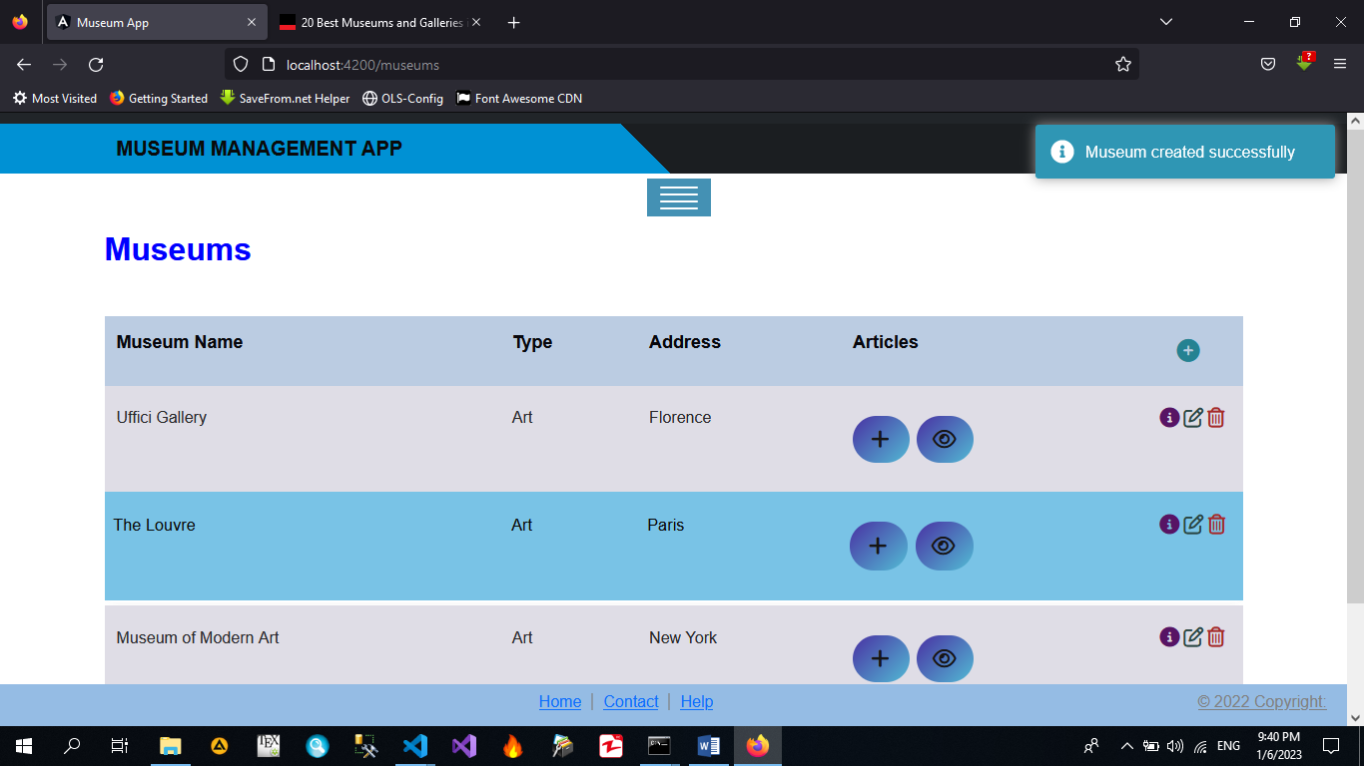

* Deleting a museum

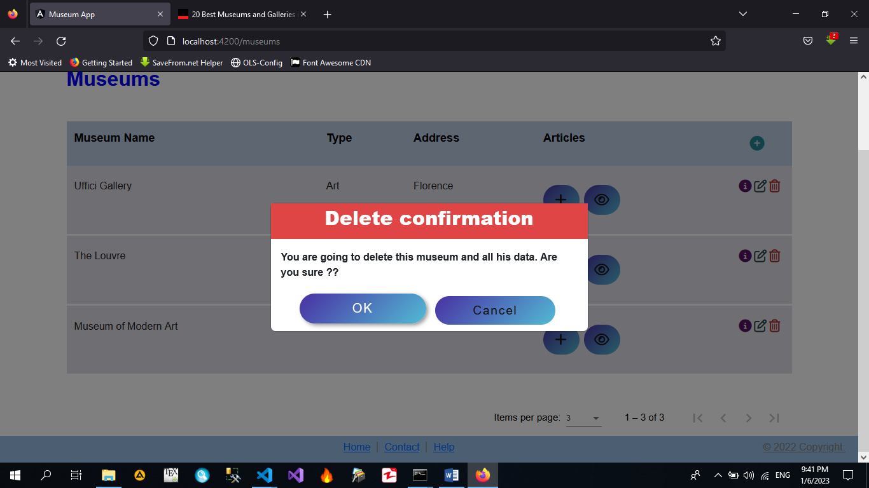

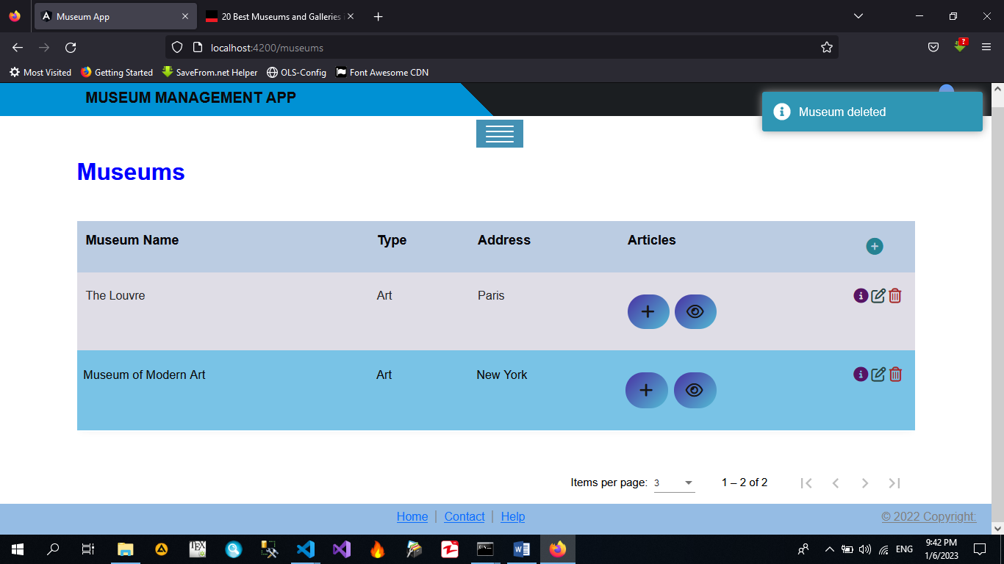

* We can see the articles in any museum by clicking in the button with the eye in the column Articles.

Clicking in the eye in The Louvre:

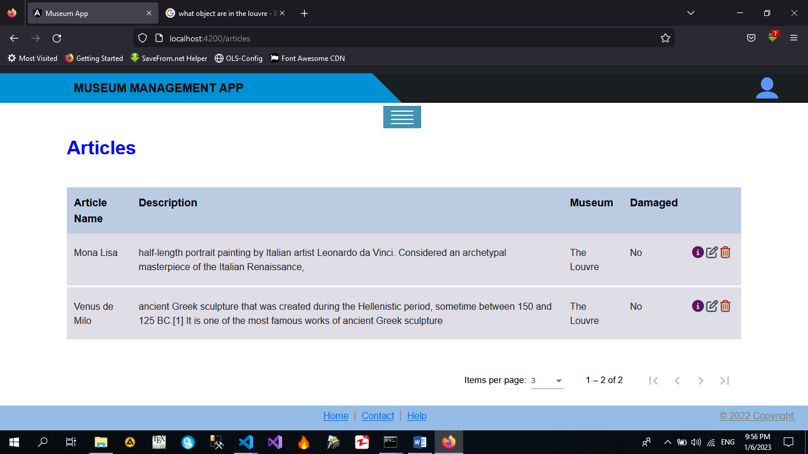

* Here we can see the info of the articles of the Louvre, edit the articles to change the description or relocate of museum, and delete the articles. If we relocate the Mona Lisa:

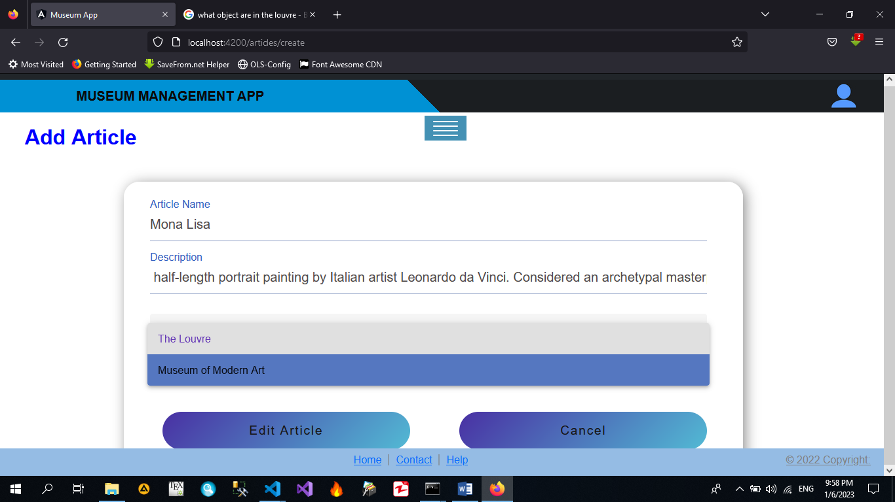

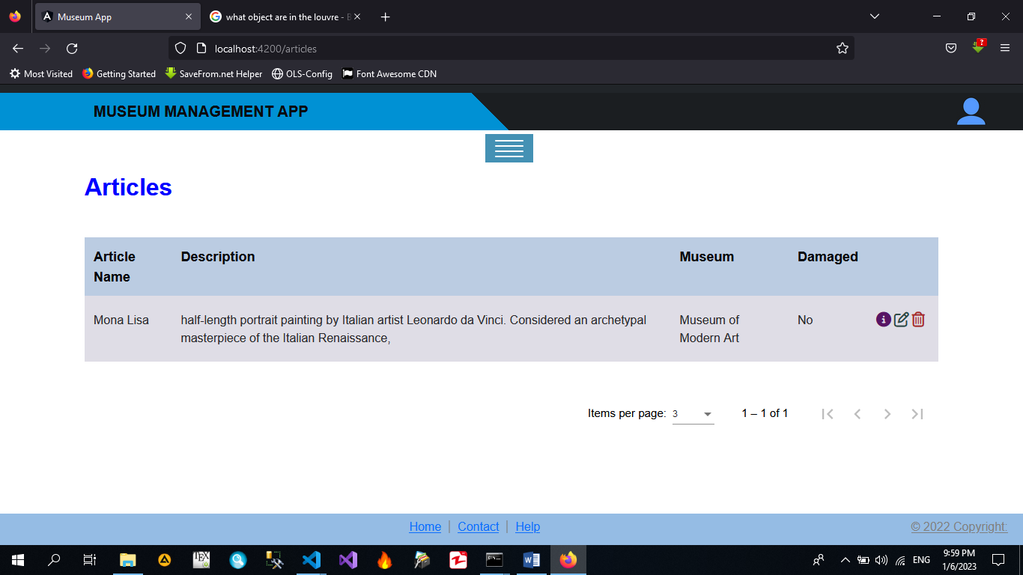

* Finally, in the button with a Plus in the View of Museums, we can create new Articles:

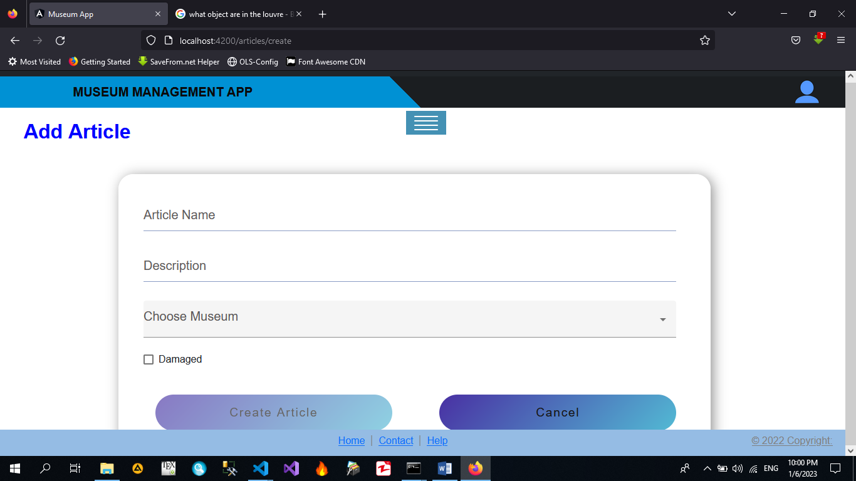

* By completing the form and click in Create Article, the new Article is created with data provided, this article can be edited in any time to set as damaged or relocate or change the description.